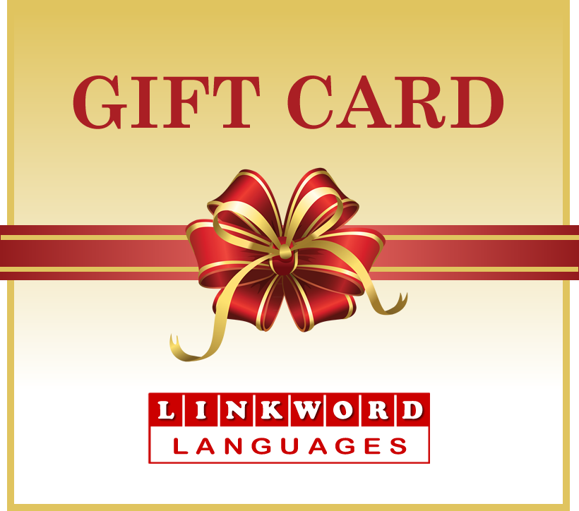

GIFT CARD AMOUNT: | £
GIFT CARD CODE:
TO:
FROM:
MESSAGE:
To redeem your Gift Card please visit our website and enter the Gift Card number (e.g. ABCD-1234-EFGH-5678) in the ‘HAVE A GIFT CARD’ section of the shopping basket during checkout. The card’s value will be deducted from the total purchase cost.
https://www.linkwordlanguages.com
Tel: 01792 402001 | Email: enquiries@linkwordlanguages.com
Linkword Languages, 92 Westport Avenue, Swansea, SA3 5EF, UK

